**SPRINT – 1**

**DATA COLLECTION:**

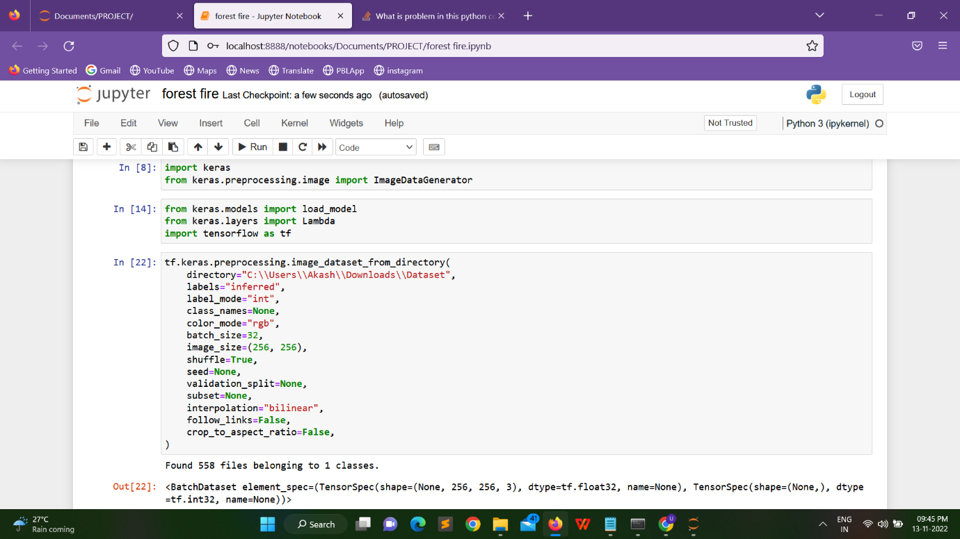

**IMAGE PREPROCESSING:**

